
Asian School of Management and Technology
(Affiliated to Tribhuvan University)
Gongabu, Kathmandu
Full Marks: 60
Time: 3 Hrs.
SET B
Preboard Examination 2080
BIM / Third Semester / IT 237: Web Technology I

Candidates are required to answer the question in their own words as far as practicable.
Group A
Brief Answer Questions: [ 1 x 10 = 10 ]
- What is HTTP
- Define dynamic web page?
- How to define inline frame in HTML?
- Which event is used to show pop up while page is lunched by user?
- Why is the use of CSS?
- Define @media query.
- Define cookies.
- Why do we need AJAX?
- Define XSLT and Xpath.
- What is XML Schema?

Group B

Short Answer Questions: (Attempt any Five Questions) [ 5 x 3 = 15 ]
- How do you handle click event using JQuery?
- What do you mean by link? Explain different links
- What is external stylesheets? Explain the advantage and disadvantage of using external stylesheets.
- What is XML? How it differs from XML? Explain with proper section of code
- WAP to find the age from given date of birth.
- Explain structure of a JSON file? Also explain JSON.parse() and JSON.stringify()
Group C
Long Answer Questions: (Attempt any Three Questions) [ 3 x 5 = 15 ]
- What do you mean by URL? Differentiate between absolute and relative URL. Write an example for linking to the files in same directory, sub directory, parent directory and from the root directory. Use image as reference
- What do you mean by CSS Box Model? Explain with examples.
- Write a program to create a multidimensional array of size 6 with data in them and display the array in HTML table using JavaScript.
- What do you mean by DTD? Write DTD for following XML
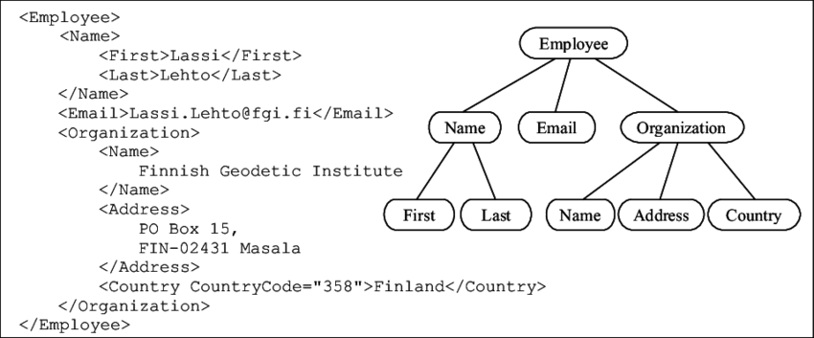

Group D
Comprehensive Answer: (Attempt All) [ 2 x 10 = 20 ]
- Differentiate between get and post methods. Why it is necessary for a developer to know type of web browsers used by users? How some information about the web browsers can be known? Also explain how cookie can be set and destroyed in JavaScript.
- Differentiate between JavaScript object and JSON. Create any JavaScript object of a student. Create a html having “Your Details” in <h1> tag and also create a button “generate”. Write JQuery code to display data of student object when user clicks on “generate” button. Your output must be as follows:





